Program No.07
PART A
(PART A: TO BE REFFERED BY STUDENTS)
A.1 Aim: Create an application to implement Node JS modules- customised module like Calculator and inbuilt modules: http, url, fs.

A.2 Prerequisite:

Javascript

A.3 Outcome:
After successful completion of these applications students will be able to
Understand and implement modules in Node Js
A.4 Theory:
- Node.js is an open-source server side runtime environment built on Chrome's V8 JavaScript engine.
- It provides an event driven, non-blocking (asynchronous) I/O and cross-platform runtime environment for building highly scalable server-side application using JavaScript.
- Node.js can be used to build different types of applications such as command line application, web application, real-time chat application, REST API server etc.
- However, it is mainly used to build network programs like web servers, similar to PHP, Java, or ASP.NET.
- In a browser, global scope is the window object. In Node.js, global object represents the global scope.
- To add something in global scope, you need to export it using export or module.export. The same way, import modules/object using require() function to access it from the global scope.
- For example, to export an object in Node.js, use exports.name = object.
- In built modules include http, url, fs
- Node.js has a built-in module called HTTP, which allows Node.js to transfer data over the Hyper Text Transfer Protocol (HTTP).
- The HTTP module can create an HTTP server that listens to server ports and gives a response back to the client.
- The URL module splits up a web address into readable parts.
- The Node.js file system module allows you to work with the file system on your computer.
Note : Implement file read, write, append, close and delete in fs module.
Tasks to be completed:
- Create a basic HTTP server in node js with http module
- Create a server that prints the URL requested by the client.
- Write a program that displays current date and time when the server is accessed.
- Build a simple calculator using URL parameters: Example: URL sent form browser is in the format: http://localhost:3000/?a=10&b=5
- Implement all the file operations using fs module
- Display file contents line by line on browser.

PART B
(PART B: TO BE COMPLETED BY STUDENTS)
(Students must submit the soft copy as per following segments within two hours of the practical. The soft copy must be uploaded on the Blackboard or emailed to the concerned lab in charge faculties at the end of the practical in case the there is no Black board access available)
Roll No. A006 | Name: AKSH SONI
Program :MCA | Division:A
Batch:B1 | Date of Experiment: 16/03/2026
Date of Submission: 16/03/2026 | Grade :

B.1 Output :
Task 1
const http = require('http');

const server = http.createServer((req, res) => {
res.write("Hello! Node.js Server Working");
res.end();
});

server.listen(3000, () => {
console.log("Server running at http://localhost:3000");
});

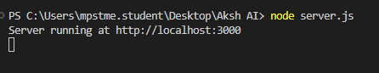
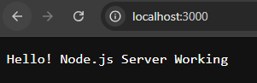
Task 2
const http = require('http');

http.createServer(function (req, res) {
res.write("Requested URL: " + req.url);
res.end();
}).listen(3000);

console.log("Server running at port 3000");

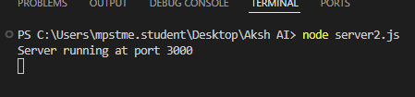
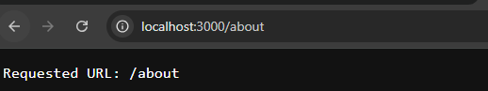

Task 3
const http = require('http');
const url = require('url');

http.createServer(function (req, res) {

const q = url.parse(req.url, true).query;

let a = parseInt(q.a);
let b = parseInt(q.b);

let sum = a + b;

res.write("A: " + a + "<br>");
res.write("B: " + b + "<br>");
res.write("Sum: " + sum);

res.end();

}).listen(3000);

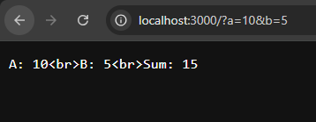
Task 4
const http = require('http');

http.createServer(function (req, res) {

const date = new Date();

res.write("Current Date and Time: " + date);
res.end();

}).listen(3000);

console.log("Server running...");

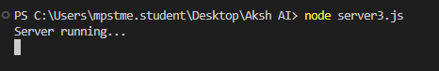
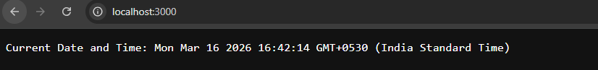
Task 5
const fs = require('fs');

fs.writeFile('demo.txt', 'Hello NodeJS', function (err) {
if (err) throw err;
console.log("File created");
});

fs.appendFile('demo.txt', '\nWelcome to FS module', function (err) {
if (err) throw err;
console.log("Data appended");
});

fs.readFile('demo.txt', 'utf8', function (err, data) {
if (err) throw err;
console.log(data);
});

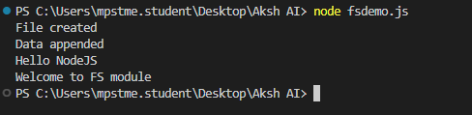
Task 6
const http = require('http');
const fs = require('fs');

http.createServer(function (req, res) {

fs.readFile('demo.txt', 'utf8', function (err, data) {

if (err) throw err;

const lines = data.split('\n');

lines.forEach(function (line) {
res.write(line + "<br>");
});

res.end();
});

}).listen(3000);

console.log("Server running...");

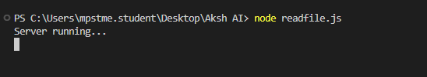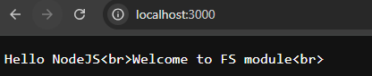

B.2 Observations/Learning:
• Learned how to create a basic HTTP server using the http module in Node.js.
• Understood how the server handles client requests and sends responses.
• Learned how to access and display the URL requested by the client.
• Understood how to display current date and time dynamically using JavaScript in Node.js.
• Learned how to use the url module to extract parameters from the browser URL.
• Implemented a simple calculator using URL parameters.
• Learned how to perform file operations such as read, write, append, delete, and close using the fs module.
• Understood how to read file contents and display them line by line on the browser.
• Gained practical knowledge about built-in modules and modular programming in Node.js.

B.3Conclusion:
Thus, the program to implement Node.js modules including built-in modules (http, url, and fs) and a customized calculator module was successfully executed. Through this experiment, we learned how to create a server, process client requests, perform calculations using URL parameters, and execute file system operations. The experiment helped in understanding the working of modules in Node.js and their role in building scalable server-side applications.

